

Massivit

HOW-TO GUIDE

Filling up models with expanding polyurethane foam

[www.massivit.com](http://www.massivit.com)

The information provided in this document is believed to be accurate and reliable. However, no responsibility is assumed by MASSIVit 3D for the use of this document or for the performance of any materials mentioned. MASSIVit 3D reserves the right to make changes to this document or any material included in it at any time and without notice.

Published on December 2017

© Copyright MASSIVit 3D 2017

CONTENT

Introduction 4

Expanding Polyurethane Foam Types 4

Availability 5

Safety 5

How To Use 6

Summary 10

INTRODUCTION

The Massivit 1800 3D printer produces large scale, light weight and hollow objects that often require more strength and durability at end-use. The following document is designed to assist Massivit 1800 3D printer owners and operators to enhance the strength and durability of their Massivit printed objects with Polyurethane foam.

Expanding polyurethane foam is easy to use and becomes rigid and strong after curing.

Expanding polyurethane foam is easy to use and becomes rigid and strong after curing. It can be used as a lightweight filling material to give hollow 3D printed objects additional strength and durability. With large or complex objects, a metal construction joint with foam filling is required to maintain structural integrity and provide long-lasting durability, but is not suitable for 3D-printed objects that include internal illumination.

If you have not previously used expanding foam, you are urged to view several YouTube movies to understand the speed and magnitude of foam expansion. In addition, they will also give you some working tips that you may find beneficial. See for example:

* *Mixing Polyurethane Foam Liquid* (mixing and foam expansion)  
  <https://www.youtube.com/watch?v=EKAVeSB3YTs>
* *Molding Foam demonstration* (mixing, expansion, and mold filling).  
   <https://www.youtube.com/watch?v=RQbfGSttIFU> )
* *Alumilite Rigid Foams* (different ratios of expansion foams) <https://www.youtube.com/watch?v=s0-yGzcLFhM> ).

EXPANDING POLYURETHANE FOAM TYPES

There are two main types of expanding polyurethane foam: rigid and flexible. This document will address only the use of rigid foam.

Rigid foams vary by their final or expanded “density” once cured. Density is the major indicator of the relative strength of rigid foam. The more a foam expands, the more space it fills. Foam types with higher densities are stronger than those that are less dense.

There are two methods for measuring the density of foam:

1. The weight of the material for a defined volume (for example, 3 lb./ft3 or 48Kg/m3)
2. Its volumetric expansion or how many times the material will expand (for example, 18 times)

*See figure 1*

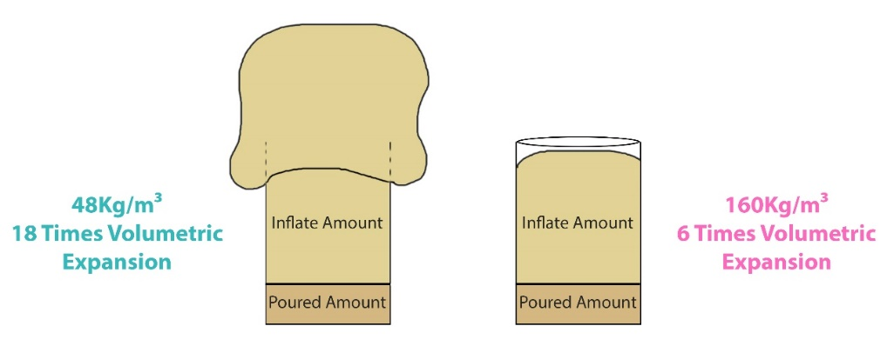AVAILABILITY

***Figure 1***

Expanding polyurethane foams are manufactured by many global and local vendors. Since they may vary in performance, we highly recommend testing a new product before using it in a commercial project, as over-expansion could damage the 3D-printed object.

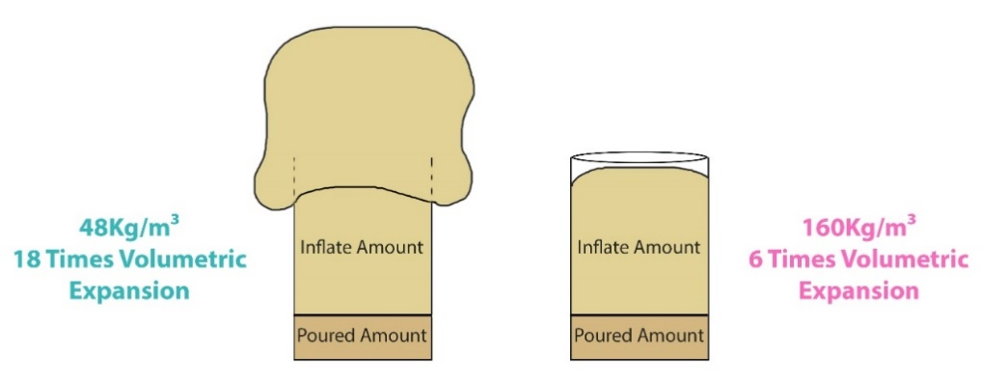Two foam materials with worldwide availability have been used in Massivit’s Applications Lab and found to be suitable for filling 3D models:

Vendor: Smooth-On, product: *Foam-it* series.

See in <https://www.smooth-on.com/product-line/foam-it/>

Vendor: Polytek, product: *PolyFoam R* series

See in <https://www.polytek.com/products/polyfoam-r-5-casting-foam>

SAFETY

Note

Expanding polyurethane foams are not to be confused with expanding foam sealants in aerosol spray cans. Those foams will not work for filling an object.

Before starting to work with the expanding foam, carefully read the **Safety Data Sheet** of the product and follow all instructions. Do not use a product without a safety data sheet. You should also cover your working area to protect it from foam spills, and always work with long sleeves and plastic gloves

HOW TO USE

### Model Preparation

Make sure the 3D printed model is fully cured. If there are any small holes in the model, they must be sealed to prevent the foam from leaking through the model.

### Mixing Ratio

Expanding polyurethane foam kits contain two liquid materials in separate containers. We will refer to them here as material A & material B. *See figure 2*

***Figure 2***

Once materials A and B are mixed, a chemical reaction occurs that causes the mixture to rapidly expand and become rigid foam.

Typically, the mixing ratios between materials A and B are one to one by volume (1:1 ratio), but in any usage, it is imperative to follow the mixing ratio in the manufacturer's instructions.

Note

Always work with small portions of material to prevent excess heat and overflow.

### Preparing and Adding the Mixture in Small Portions

To successfully work with expanding polyurethane foam, it is crucial to work with small amounts because of the exothermic chemical reaction that occurs after the materials are mixed. During this reaction, the mixture heats up as it expands. The larger the amount of materials used, the faster and hotter the process will be. If substantial portions of the A and B chemical materials are used, the mixture can generate enough heat to ruin its own material properties or the 3D-printed model.

Another reason to work with small portions is to ensure that it fills evenly all parts of the model and does not expand and harden before all hollow areas of the model are filled. It is recommended to use no more than 1 liter (33 oz.) of each chemical when creating expanding polyurethane foam.

To prevent overheating or ruining the model, it is also important to wait 15-30 minutes between pouring each batch of the mixture. While filling the model, you should check the temperature by carefully touching its sides. If it feels uncomfortably hot, stop filling the model with the foam mixture and let it cool for a while before continuing.

Using the correct ratio of the mixture is extremely important! When the ratio is wrong, the material properties of the foam will be compromised. Nevertheless, a slight deviation will not have a significant effect.

### Mixing Tips

A convenient practice for mixing is to use two identical and transparent containers, such as disposable plastic drinking cups, and fill them to the same height (one with material A, and the other with material B). Then, pour both components into a third, disposable container for mixing. *See figure 3*

***Figure 3***

Thoroughly mix the two materials in the third container until the mixture becomes a uniform color. Then quickly pour the mixture into the model before the material begins to expand. It is important to work quickly as the reaction starts to occur **within several seconds**.



Note

To understand how quickly a particular foam expands, it is highly recommended to conduct a test mix in advance.

### Pouring Tips

***Figure 4***

* **Maximizing adhesion:** When pouring the liquid mixture into the model, it is important that the mixture touches as many sides or walls of the model as possible to maximize the adhesion between the model and the filling. This also ensures that the filling flows to all hollow areas of the model. This can be achieved by slightly rotating and leaning the model from side to side while pouring the mixture. If needed, use a funnel and clean it immediately after use. *See figure 4*



Note

Denser foams generate more heat and require slower, more methodical work, but they are more rigid and significantly reinforce vulnerable areas of the model.

* **Do not add objects:** Avoid adding other objects into the mixture inside the model (such as a mixing container or stirrer), as it may prevent the equal distribution and maximum adhesion of the filling material inside the model.
* **Allow room for expansion:** Do not pour material into small and confined areas as this may create cracks in the model when the expandable material has no more area to expand. Always make sure that the material has a room to expand whether inside or outside the model. Any excess material outside the model can be removed (cut) afterwards.
* **Filling broad spaces:** In broad spaces of the model, a lower density material can be used (18-30 times volumetric expansion).
* **Filling confined or weaker spaces:** Weaker parts of the model such as small areas, areas that carry a lot of weight, or areas that serve as connection between two parts, should be filled with a higher density foam to give the needed strength to the area (approximately 10-8 times volumetric expansion). *See figure 5.*

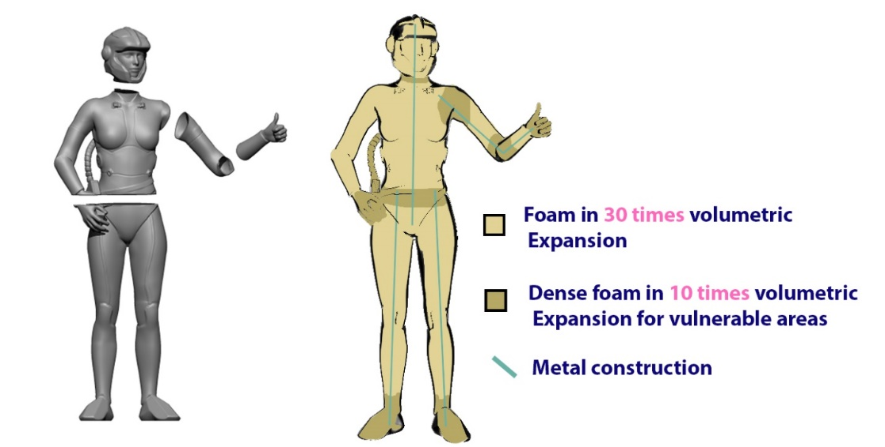

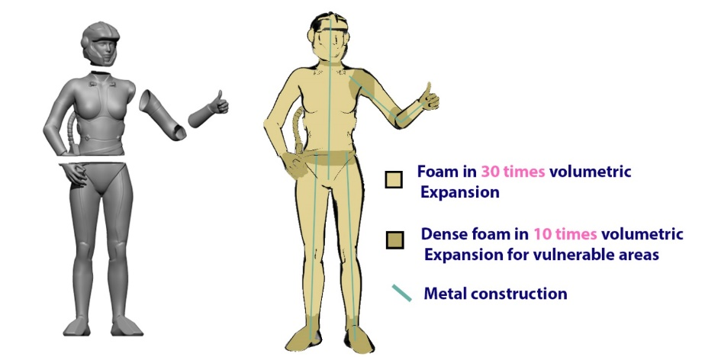

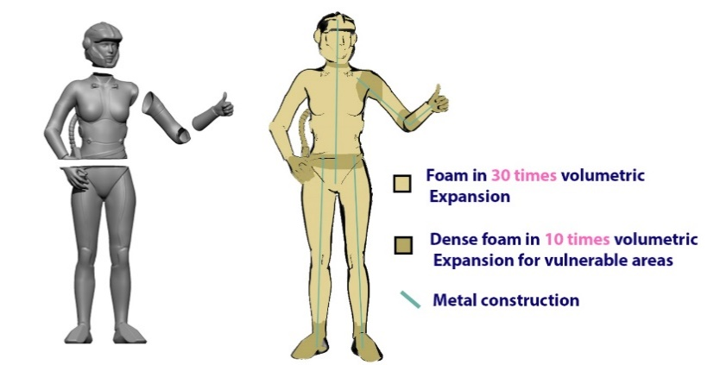

***Figure 5***

### Proper order of assembly

When a model consists of multiple parts, it is important to produce it in a way that will enable the optimal insertion of the expanding polyurethane foam.

Pour the foam through existing open areas (such as the bottom of the model) or make holes in places that will be hidden later as this is preferable to cutting holes that must be sealed later.

It is highly recommended to fill the parts of the model with expanding foam before joining them together. This enables better control over the filling process and eases final assembly. This is especially relevant when the model includes long and narrow geometry, such as arms or legs.

Note

For more details about gluing parts together or adding metal construction to a model, please refer to the dedicated Application Notes on those subjects.

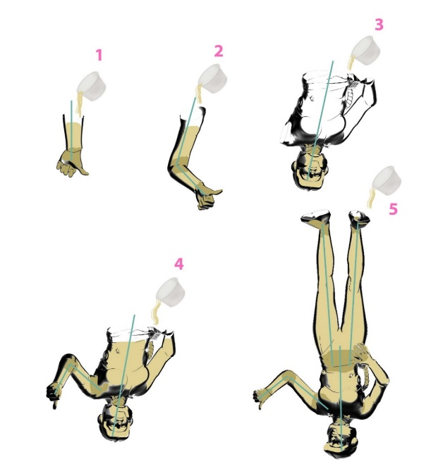When filling up each part, leave some empty space at end from where you are filling. This empty area will be filled together with the second part- after assembling them together. Using more dense foam for the connection areas will provide extra strength to connection points. *See figure 6*

***Figure 6***

# SUMMARY

Expanding polyurethane foams are easy to use as a lightweight filling material and add needed strength and durability to hollow 3D printed models. Adding metal construction can improve structural integrity and provide the model with long-lasting durability.

Massivit is hopeful that you found this document productive, and that the best practices, guidelines and tips that we have learned from our own experience and from the experience of Massivit customers are beneficial to you.

For further technical questions about the process of filling models with expanding foams, please contact your Massivit support representative or [support@massivit.com](mailto:support@massivit.com).



11 Pesah Lev St., Lod 712936. Israel | Tel: +972-8-6519486 | Fax: +972-8-6900758

[www.massivit.com](http://www.massivit.com) | [info@massivit.com](mailto:info@massivit.com)

© 2017 Massivit 3D Printing Technologies Ltd. All rights reserved. Massivit 3D, GDP Gel Dispensing Printing, Massivit 1800 and the related logos and slogans are trademarks of Massivit 3D Printing Technologies Ltd. All brand names are the property of their respective owners and may or may not be trademarked.